**HW 4**

**Advanced SQL**

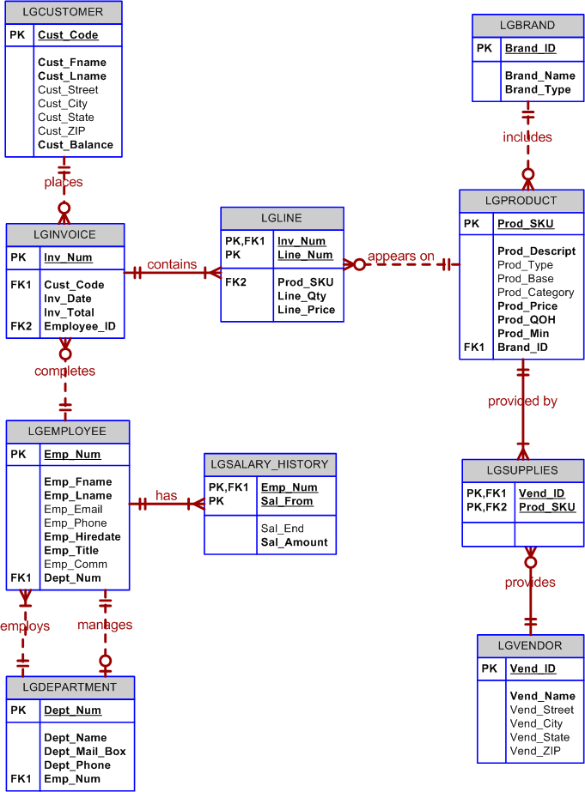Use the **Ch08_LargeCo** database shown in Figure P8.19 to work Problems 19-27. For problems with very large result sets, only the first several rows of output are shown in the following figures.

**Figure P8.19 Ch08_SaleCo2 Database Tables**

1. **a) Write a query to display the products that have a price greater than the average price of all the products in the lgproduct table.**

**b) Write a query to display the brands (using their brand_id) that have a brand average price greater than the average price of all the products in the lgproduct table.**

**c) Write a query to display the products that have a price greater than the average price of the products from the same brand.**

1. **Write a query to display the current salary for each employee in department 300. Assume that only current employees are kept in the system, and therefore the most current salary for each employee is the entry in the salary history with a NULL end date. Sort the output in descending order by salary amount.**

**Figure P8.20 Current salary for employees in department 300**

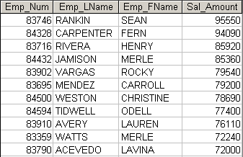

1. **Write a query to display the starting salary for each employee. The starting salary would be the entry in the salary history with the oldest salary start date for each employee. Sort the output by employee number.**

**Figure P8.21 Starting salary for each employee**

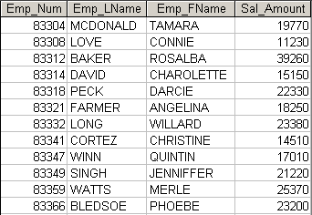

1. **Write a query to display the invoice number, line numbers, product SKUs, product descriptions, and brand ID for sales of sealer and top coat products of the same brand on the same invoice.**

**Figure P8.22 Invoices for sealer and top coat of the same brand**

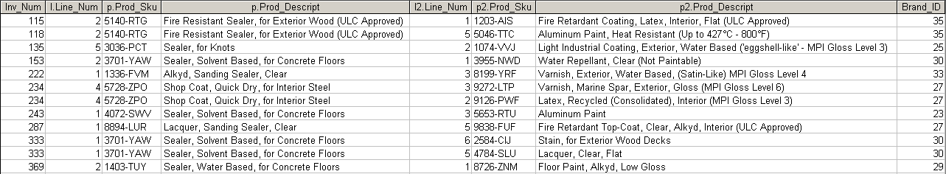

1. **The Binder Prime Company wants to recognize the employee who sold the most of their products during a specified period. Write a query to display the employee number, employee first name, employee last name, e-mail address, and total units sold for the employee who sold the most Binder Prime brand products between November 1, 2011, and December 5, 2011. If there is a tie for most units sold, sort the output by employee last name.**

**Figure P8.23 Employees with most Binder Prime units sold**



1. **Write a query to display the customer code, first name, and last name of all customers who have had at least one invoice completed by employee 83649 and at least one invoice completed by employee 83677. Sort the output by customer last name and then first name.**

**Figure P8.24 Customers with invoices filled by employees 83649 and 83677**

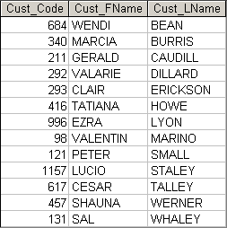

1. **LargeCo is planning a new promotion in Alabama (AL) and wants to know about the largest purchases made by customers in that state. Write a query to display the customer code, customer first name, last name, full address, invoice date, and invoice total of the largest purchase made by each customer in Alabama. Be certain to include any customers in Alabama who have never made a purchase (their invoice dates should be NULL and the invoice totals should display as 0).**

**Figure P8.25 Largest purchases of customers in Alabama**

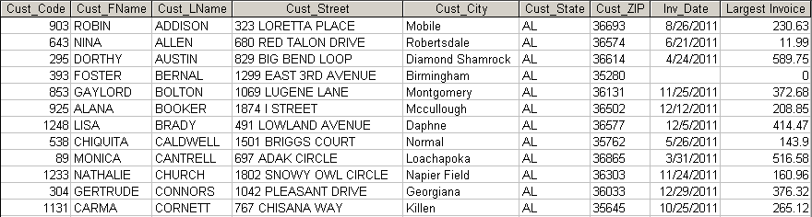

1. **One of the purchasing managers is interested in the impact of product prices on the sale of products of each brand. Write a query to display the brand name, brand type, average price of products of each brand, and total units sold of products of each brand. Even if a product has been sold more than once, its price should only be included once in the calculation of the average price. However, you must be careful because multiple products of the same brand can have the same price, and each of those products must be included in the calculation of the brand’s average price.**

**Figure P8.26 Average price and total units sold of products by brand**

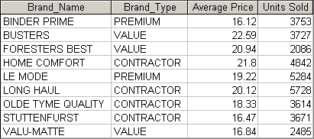

1. **The purchasing manager is still concerned about the impact of price on sales. Write a query to display the brand name, brand type, product SKU, product description, and price of any products that are not a premium brand, but that cost more than the most expensive premium brand products.**

**Figure P8.27 Nonpremium products that are more expensive than premium products**

